Project Overview

### **Essential Innovations LLC**

AICommunityMobile

#### **Context:**

Kentucky's immigrant and refugee communities face significant challenges in navigating workforce entry and participation, often complicated by language barriers and complex bureaucratic systems.

#### **Problem:**

Develop an AI-powered multilingual application that helps immigrants and refugees in Kentucky access and understand workforce-related information, requirements, and opportunities in their primary language.

#### **Requirements:**

* •Implement multilingual support for both text and voice interactions
* •Create web scraping system for government and advocacy websites
* •Build AI-powered Q&A system with source citations (similar to Perplexity)
* •Develop both web and mobile applications with offline capabilities
* •Implement real-time translation for user interactions
* •Create simple admin interface for non-technical staff
* •Include document processing for form completion assistance
* •Build notification system for policy updates
* •Integrate with relevant government APIs where available
* •Ensure data privacy and security compliance
* •Provide comprehensive documentation for non-technical administrators

**Presentation Requirements**

🎮

**Live Demo (Preferred)**

Show your product in action with a live demonstration of key features.

🎯

**Slide Deck**

Present a comprehensive overview including:

Problem - What issue are you solving?

Solution - How does your project address it?

Outcome - What are the results and benefits?

How it works - Technical implementation

Team - Who contributed what?

<https://docs.google.com/presentation/d/1lBD3rA1fe3HMjcErkoJn9TU1xg3NRMg_ezplriQT3wU/edit#slide=id.g339184218ca_0_17>

Team/Agenda

## Team Members

* Keenrruy Murillo / [keenrruyjr@gmail.com](mailto:keenrruyjr@gmail.com)
  + 5026561843
  + Familiar with python, algorithms, data structures, backend
* Jose Gonzalez / [jose37871@gmail.com](mailto:jose37871@gmail.com)
  + 502-618-9981
  + Familiar html, css, javascript/react
* Annika Chadha / [annikachadha8@gmail.com](mailto:annikachadha8@gmail.com)
  + 502-644-6541
  + Familiar with java and python
* Dalton Powell / [dalton@getswell.app](mailto:dalton@swell.app)
* (859) 414 3130
  + Familiar with web dev, react
* Nghia Truong / [nghiatruong281202@gmail.com](mailto:nghiatruong281202@gmail.com)
  + Backend, algorithms, data structures
  + 502 309 5347

## Responsibilities

**Group Wide:**

* Provide comprehensive documentation for non-technical administrators
* Implement multilingual support for both text and voice interactions (prioritizing text, audio can be added if we have time)
  + **Google translate API**
  + Allow transcription
  + Voice interaction can be in the form of a single audio file, not a live conversation
* Implement real-time translation for user interactions
  + Websocket
* Include document processing for form completion assistance
  + Allow user to upload images/files
  + A scanner to read the images
  + Autofill information
  + Prompt user what information to fill and where
* Build notification system for policy updates
  + In app notifications
  + Emails (if permitted)

**Backend Team (Keenrruy & Nick)**

* Integrate with relevant government APIs where available
  + Ensuring no hallucination
    - Guardrails AI, NeMo Guardrails
  + Taking care of connection issues
    - Functions that frequently check on the connection
    - Python Socket Library
  + API keys are private
* Ensure data privacy and security compliance
  + Encryption:
    - **cryptography**
  + Hashing:
    - **hashlib**
  + Data validation
    - **(json schema)**
  + 2 databases: user and admin
    - **MySQL**
    - User: personal information which can be used to auto fill
* Build AI-powered Q&A system with source citations (similar to Perplexity)
  + Directly implement **Perplexity API**
* Create web scraping system for government and advocacy websites
  + **BeautifulSoup** python library for html and beautifulsoup

**Frontend Team (Jose, Annika, Dalton)**

Front end tasks:

* Clear search bar after the search query is sent
* Give function to the language buttons on the top of the web page (is this to let the back end know what language is being expected? Or will this translate all of the text on LandingPage.jsx and SearchBar.jsx)
* Make sure the two display boxes work to show a job desc in english and the selected language (implementing translation logic to other-language-version

Backlog & Stretch Goals

* •Bonus: Voice recognition and response system
* •Bonus: Automated form filling assistance
* •Bonus: Community feedback integration

Judging Philosophy

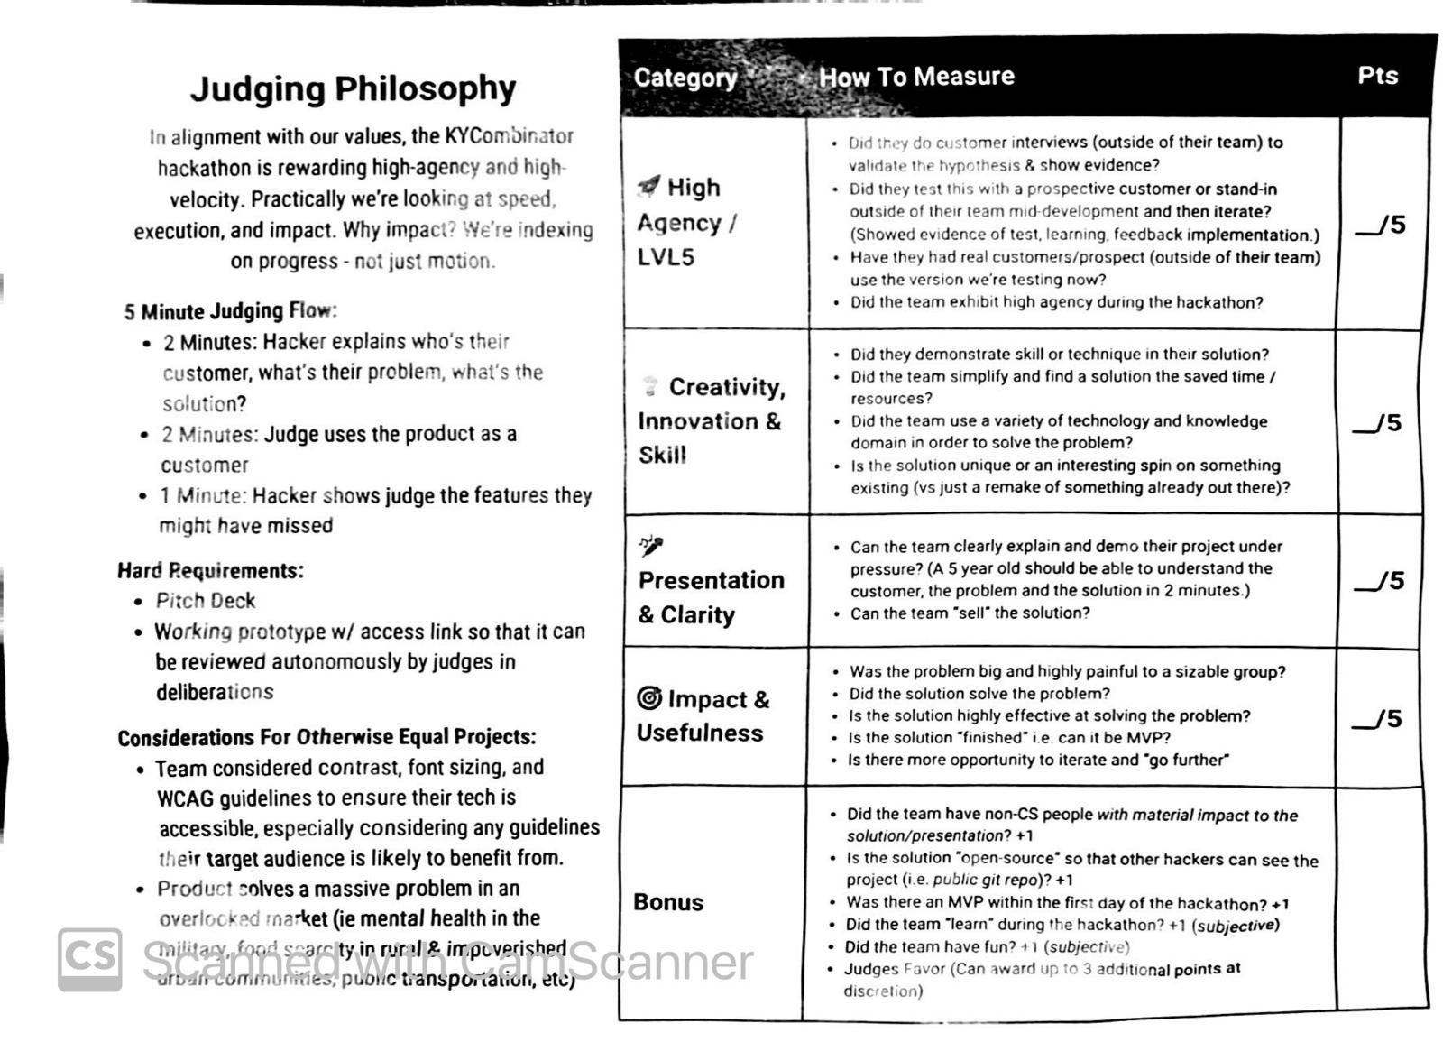

Shared Resources

* <https://jobapis.github.io/open-source/>